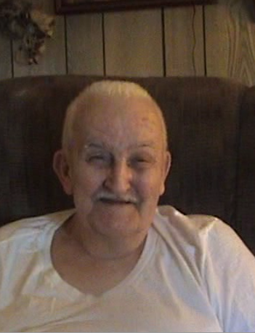
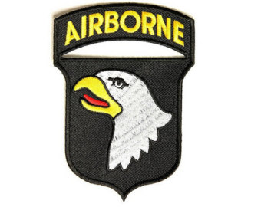
CLANCY LYALL
U.S. AIRBORNE
&
SOLDIER OF B COMPANY

A WISH TO JOIN THE AIRBORNE
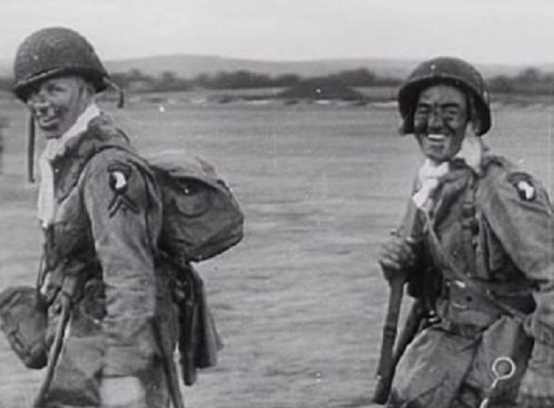
“I went to camp Blanding in Florida for my training stayed there for 6-8 weeks volenteered for Airborne. I then went to Fort Benning, there were no buildings here at the time, after this he went to an Airborne school to learn how to jump”. “The nutcracker was the only bad task, that was Harness training the rest of it was good”. “Before the Jump I was briefed twice for the mission, I was in heavy weapons I tested the weapons before we jumped. We stayed busy, firends wrote last wills. On the day before I could not leave batallion section as the day came closer I knew I was going to jump but not sure where, we wanted to get on with the mission. Once the battalions knew the orders we knew, they spoke to no one about the mission.”
THE JUMP
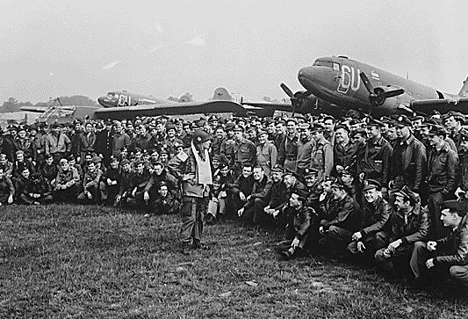
“On the plane the mood of the soldiers was that no one would say if they were scared, they tried not to think about the event, it did not bother us until they hit the french shoreline. The flak hit soldiers in the planes, I was happy to jump out of the plane, you don't think too much, It's instincts. I was never hit by any fire from the ground, I know if we jumped any higher we all would have been killed. When I got to the ground I did not know where I was, I ran in the direction of the sound of gunshots, a soldier from the 82nd helped me and Campbell get out of the parachutes. We ran into German soldiers within 1000 yards later, we heard firing and moved to that sound and we ran into B company of the 82nd airborne. We took the town of St. Mary Gleese within 3 hours, we remianed with B company for three days, then I rejoined with the 101st at Carentan. I reported to Harry Hughes and then picked up my gear and moved out”.

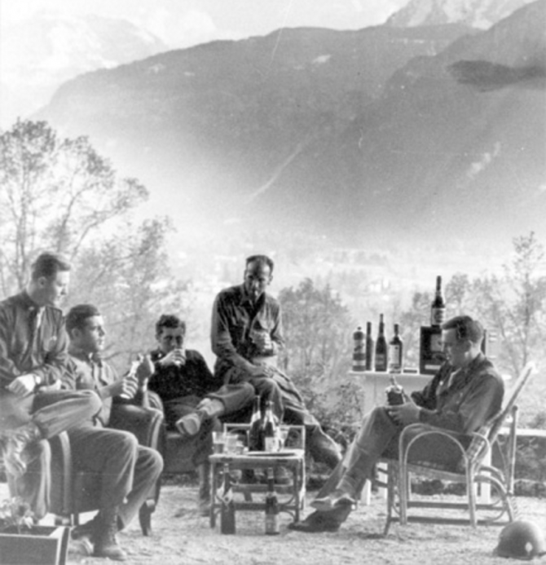
HITLER'S HOUSE PARTY
“It was quiet in Noville, the German tanks were being assaulted by airplanes at this point, we were called out back to Maumilaun and we spent a few weeks there. We went from town to town and then we soon reached the banks of the Rhine. We then were told to go to Munich and Bavaria the orders were to breach Austria and fight the german Guerillas in the mountains. When we got there we got to Hitler's house and the radios were still on. We found a jeep in the Kitchen and the house had an elevator. We found the liquor cabinet, Spears had us send trucks to get the booze. We spent a few days there enjoying ourselves, the war had ended by then”.

DISCOVERY OF HORROR
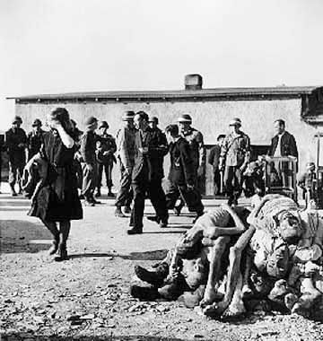
“Bull came across the camp and the stench was horrible, we all went down to see a work camp I was one of the first people in the camp. Outside of Austria, we walked into the barracks and there were dead people everywhere and I started feeding them, we were ordered to stop since some died from this. We followed the railroad down about a mile and a half and we found another camp, we shot the german guards and busted down the gates”. “We saw prisoners rip apart guards, one prisoner spoke english and showed the soldiers 8-milimeter film reels I saw the filmed experiments of the German scientists on children they would perform outragious experiments and write down the results.” “We got all the tapes, I saw the ovens and we caught a few German officers before the inmates got to them. Patton's third army came in and we left, there is no way they did not know in town they used these prisoners we made an oblivious town clean up the bodies at the camp”.

